MDSD - xText Math Compiler

# Status

The math compiler is working and makes use of both externals and functional-style

# Links

xText: <https://github.com/thevinge/MDSD-MathCompiler/blob/master/org.xtext.mdsd.mathcompiler/src/org/xtext/mdsd/MathCompiler.xtext>

Generator Xtend: <https://github.com/thevinge/MDSD-MathCompiler/blob/master/org.xtext.mdsd.mathcompiler/src/org/xtext/mdsd/generator/MathCompilerGenerator.xtend>

# Example

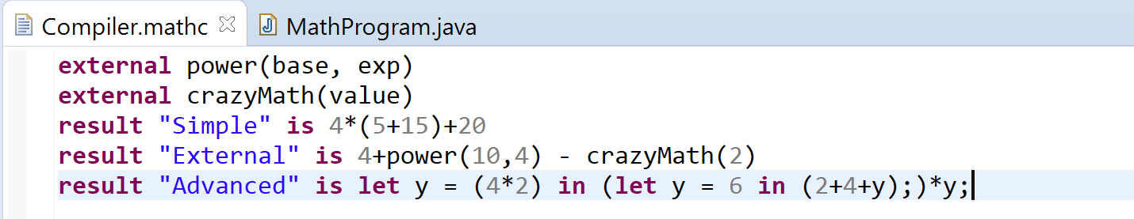

The output from the DSL:

